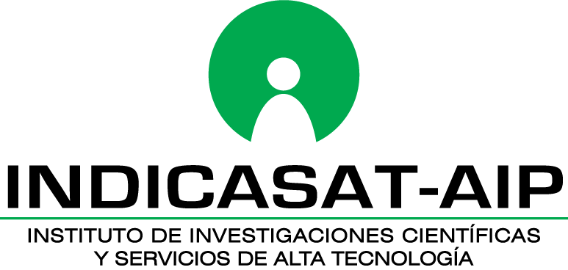

Internal Grant Call 2021
Guidelines for presenting Progress Report (PR)
The following guidelines are intended to guide the preparation and submission of the Progress Report (PR). These PR are submitted by the principal investigator after one year receiving the funds. These PR should be submitted to the INDICASAT-AIP Internal Grant Scientific Committee in order to approve the disbursement of funds for following period activities. The PR must be submitted as single PDF file, including all the attachments, using hyperlinks to annex the requested information within the document. The PR have the following sections:
Cover Page: The Cover Page includes information about the grant, PI, organization, grant period, requested budget, and abstract.
Accomplishments: This section allows INDICASAT-AIP to assess whether satisfactory progress has been made during the reporting period.
- What are the major goals of the project? List the major goals of the project as stated in the approved application. It is accepted minor changes to goals**. In such cases, please clearly state the changes to the goals during the reporting period. Also explain changes in methods from the approved application or work plan.
**Note: Major changes in objectives and scope of study are not allowed.
- Have the goals changed since the initial competing grant or previous report? Select Yes if any goal/specific aim has changed since the initial competing grant or previous report, and provide a description or explanation of changes.
Note: Describe significant deviations, unexpected outcomes, or changes in approved protocols for human subjects, vertebrate animals, biohazards and/or select agents during this reporting period.
- Human Subjects: If human subject studies are or will be different from the previous submission, include a justification and explanation of how the studies differ, and provide new or revised bioethics committee approval. Additional or modified inclusion enrollment reports may also be necessary and should be provided.
- Vertebrate Animals: If there are or will be significant changes to the uses of vertebrate animals from the previous submission, provide a justification and description of the changes. Examples of changes considered to be significant include, but are not limited to: changing animal species, changing from noninvasive to invasive procedures, new project/performance site(s) where animals will be used, etc. PI should provide a new or revised animal bioethics committee. If studies involving live vertebrate animals are planned and were not part of the originally proposed research design, provide a new animal bioethics committee approval.
Note: any new or revised bioethics committee should be attached as PDF format to the document with a hyperlink (within the final PR PDF file).
- Biohazards: If the use of biohazards is or will be different from that in the previous submission, provide a description and explanation of the difference(s).
- What was accomplished under these goals? In this section please describe: A) major activities; B) specific objectives; C) significant results, including major findings, developments, or conclusions (both positive and negative); and D) key outcomes or other achievements. Include a discussion of stated goals not met. (Note: List all products from this reporting period in Products section)
Note: Please attach a PDF file with figures, tables, manuscript draft. Figure and tables should be referred within the PR text as hyperlink (within the final PR PDF file).
- What opportunities and professional development has the project provided? In this section, please state the opportunities for training and professional development during the execution of the project. Training activities include courses or one-on-one work with a mentor. Professional development includes participation in conferences, workshops, and seminars.
Note: if the study is not intended to provide training and professional development opportunities or there is nothing significant to report during the reporting period, state Nothing to report.
- How have results been disseminated to communities of interest? In this section, indicate how the results have been disseminated to the community. Include any activity that have been undertaken to reach members of community, for the purpose of enhancing public understanding and increasing interest in learning and careers in biotechnology, bioscience and biomedicine. If Website(s) or other internet sites or social media are being used, please include URL hyperlink.
Note: if the study is not intended to disseminate information to the public or conduct similar activities, a response is not required and state Nothing to report.
- Identify and describe technologies or techniques that have resulted from these research activities and how they are being shared? In this section, report all technologies or techniques that arise from the grant. Provide a short description and state if the technology or technique falls into one or more of these product categories: audio or video, data or databases, research material, evaluation instruments, instruments or equipment, models, physical collections, protocols, software, survey instruments, interventions (e.g., clinical or educational).
Products: For this section, the investigators should report the products achieved during the reporting period.
- Are there publications or manuscripts accepted for publication in a journal or other publication (e.g., book, thesis) during the reporting period resulting directly from this award? In this section, PI must include accepted publications, or in revision process, as well as preprints which are complete and public draft of a scientific document. These publications, include both, those related to the grant award, and others related to the award scientific work. Also, books, book chapters and dissertation thesis should be reported. Please provide the URL or DOI in hyperlink format that directly send to the web source. All publications should be limited to the reporting period.
- Have inventions, patent applications and/or licenses resulted from the award during this reporting period? In this section, please indicate whether or not the study has generated patent application or licenses. It is strongly recommended to report the invention to the Center for Technological Transfer and Innovation of INDICASAT-AIP.
Participants
- What individuals have worked on the project? Provide information for each person who has worked or provide effort on the project during the reporting period. In this section, PI should provide or update the information for: (1) principal investigator(s) (PIs); and (2) any person who has worked on the project during the reporting period, regardless of the source of compensation. This includes but not limited to Co-Investigator, Faculty, Postdoctoral (scholar, fellow or other postdoctoral position), Technician, Staff Scientist (doctoral level), Statistician, Graduate Student (research assistant), Non-Student Research Assistant, Undergraduate Student, High School Student, Consultant, Other (specify).
This information includes the name and the role within the project. If an undergraduate student graduates, enters graduate school, and continues to work on the project, show that person as a graduate student. If new key personnel were included, please attach the biosketches of all of them in a PDF format using a hyperlink to the final PDF file. Key personnel are defined as the PI and other individuals (doctoral or other professional degrees, consultants) who contribute to the scientific development or execution of a project in a substantive, measurable way, whether or not they receive salaries or compensation under the grant.
Impact
- What is the impact of this project accomplishments? e.g. impact in the community and institution. In this section, the PI should list and describe the impact of project achievements during the reporting period. These impacts include three main aspects: 1) human development: provide a succinct explanation on how the project activities reinforce the training and education of personnel participating in the study. 2) Community development: explain how the project improve society understanding of the role of science and technology for its goodwill. And 3) Public policy: describe how the project achievements have shaped public policies that improve locally and globally.
Budget: Please fill out the table with the direct costs’ information for the reporting period. In the row section “Other expenses” investigators should specify expenditure to each category.
- Has the budget changed since the initial competing award or previous report? In this section, the PI should justify and describe the line and items and amounts that represent significant changes from previously recommended level.

